####if else#####

if(condition)

{

//body of if statement;

}

else{

// body of else statement;

}

1) Example: Enter your age and verify you eligible or not for the election voting using if else condition.

INPUT:

#include<stdio.h>

int main(){

int age = 0;

printf("Enter your age:");

scanf("%d",&age);

if(age<18)

{

printf("\nYou are not eligible to vote\n");

}

else{

printf("You are Eligible to vote");

}

return 0;

}

OUTPUT:

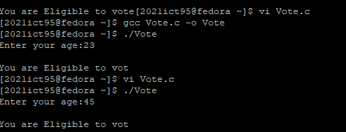

2)#####Ternary Operator#####

INPUT:

#include<stdio.h>

int main(){

int age = 0;

printf("Enter your age:");

scanf("%d",&age);

(age>=18)? printf("you can vote"):print("You are not eligible to vote");

return 0;

}

OUTPUT:

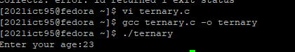

3)#####Switch Operator#####

switch (variable/expression){

case 1:

//body of case 1

break;

case 1:

//body of case 1

break;

default:

//body of default

}

EX 1:Enter the value between 1 to 7 and create a program for following output:

enter the number between 1 to 7:1

Today is Sunday

INPUT:

#include<stdio.h>

int main()

{

number = 0;

printf("Enter the number between 1 to 7");

scanf("%d",&number);

switch(value)

{

case 1:

printf("Sunday");

break;

case 2:

printf("Monday");

break;

case 3:

printf("Tuesday");

break;

case 4:

printf("Wednesday");

break;

case 5:

printf("Thursday");

break;

case 6:

printf("Friday");

break;

case 7:

printf("Saturday");

break;

default:

printf("Invalid!");

}

return 0;

}

OUTPUT:

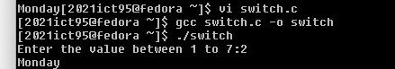

4)Give list of numbers then calculate the summation and multiplication using for loop.

1 2 3 4 5

summation: 15

multiplication: 120

INPUT:

#include <stdio.h>

int main() {

int n, i;

int sum = 0, product = 1;

printf("Enter the number of elements: ");

scanf("%d", &n);

int numbers[n];

printf("Enter %d numbers:\n", n);

for (i = 0; i < n; i++) {

scanf("%d", &numbers[i]);

}

for (i = 0; i < n; i++) {

sum += numbers[i];

product \*= numbers[i];

}

printf("Summation: %d\n", sum);

printf("Multiplication: %d\n", product);

return 0;

}

5)print the integers from 1 to 10 using while loop

INPUT:

6) Write a c program to generate and the print the fibonacci series up to a specified numbe r of terms.

the program should take the number of terms as input from the user and then display the corresponding fibonacci sequence.

INPUT:

#include <stdio.h>

int main() {

int n, first = 0, second = 1, next;

printf("Enter the number of terms: ");

scanf("%d", &n);

if (n <= 0) {

printf("Please enter a positive integer for the number of terms.\n");

return 1;

}

printf("Fibonacci Series up to %d terms: \n", n);

if (n >= 1) {

printf("%d ", first);

}

if (n >= 2) {

printf("%d ", second);

}

for (int i = 3; i <= n; i++) {

next = first + second;

printf("%d ", next);

first = second;

second = next;

}

printf("\n");

return 0;

}

OUTPUT:

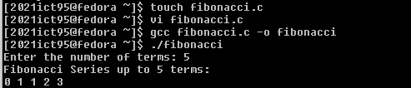

7)Write a C program to calculate the factorial of a given non - negative integer.

INPUT:

#include <stdio.h>

long long factorial(int n) {

if (n == 0 || n == 1)

return 1;

else

return n \* factorial(n - 1);

}

int main() {

int num;

printf("Enter a non-negative integer: ");

scanf("%d", &num);

if (num < 0) {

printf("Factorial is not defined for negative numbers.\n");

} else {

printf("Factorial of %d is %lld\n", num, factorial(num));

}

return 0;

}

OUTPUT:

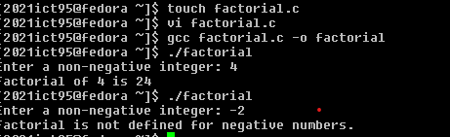

8)

Write a C program that:

Accepts two strings as input from the user.

Concatenates the two strings Displays the concatenated result.

9)

write a c program that takes a binary number (as an integer)

as input and converts it to its decimal equivalent.

INPUT:

10)

Write a C program that:

Accepts an array of integers from the user.

Finds and display the maximum and minimum values in the array.

INPUT:

11)

C program to generate Pascal’s Triangle.

OUTPUT:

No of rows = 5

1